CRAZY SENTENCES
- beach a there’s.
____________________________________________________________________________________________________________________________
- fish likes and Lucy chips.
____________________________________________________________________________________________________________________________
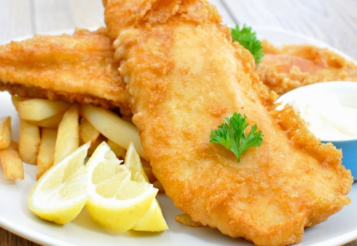
- camera Lucy so take can has photos got a she.
____________________________________________________________________________________________________________________________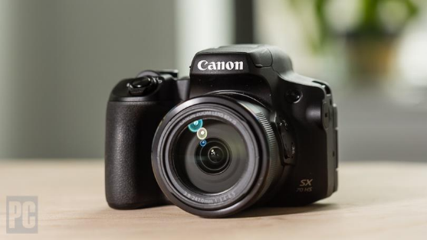

- hasn’t Yolanda headphones got can’t so she music to listen.
____________________________________________________________________________________________________________________________
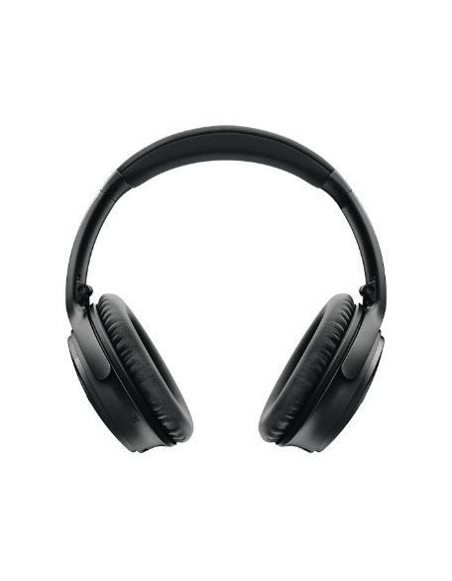

- want Elena to Lucy do and gardening.
____________________________________________________________________________________________________________________________
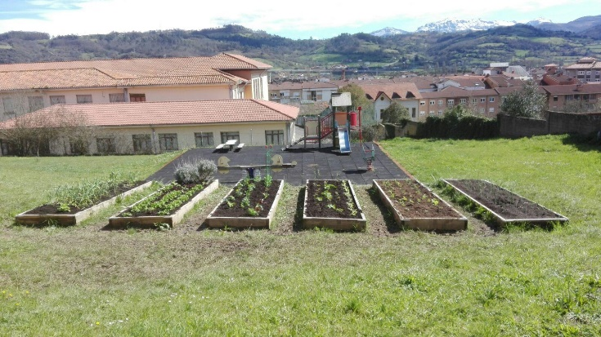

- time What does start coding?
___________________________________________________________
___________________________________________________________

